Citizens Participating in Research and Restoration
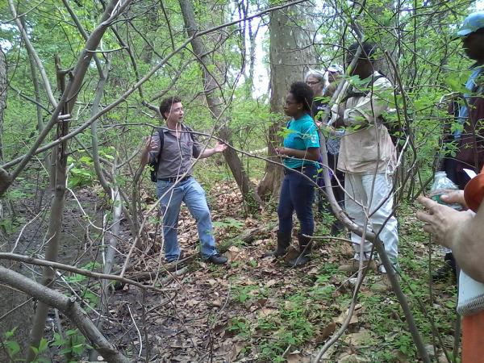

"Plant Identification and Survey Techniques"

with Dr. David A. Hewitt

Haddington Woods, Cobbs Creek Park
Meet at Bocce Court parking lot
Daggett and Vine St. 19139

This class will be offered at the following times:
Sunday September 20, 2-4 PM
Monday September 21, 1-3 PM
Monday September 21, 4-6 PM

Citizens Participating in Research and Restoration is a program designed to engage local citizens in all phases of the urban forest restoration process, including planning, implementation, monitoring and maintenance.

This program is open to the public.
To register, or for more information:
Joan.blaustein@phila.gov
215-683-0215

